EKS

Elastic kubernetes service

Go to eks

Create a cluster

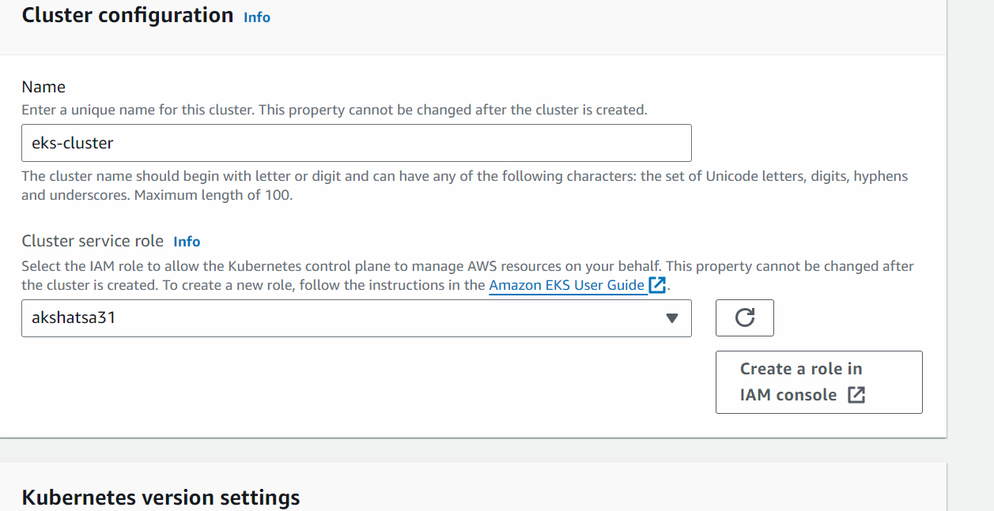

(Create a role in iam console -> next -> next)

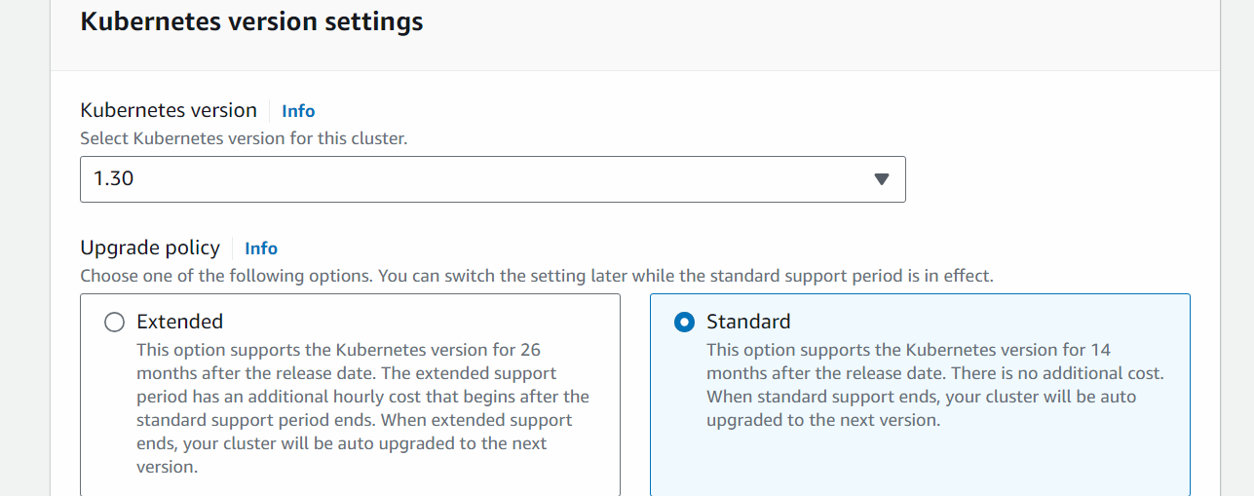

Next
######################

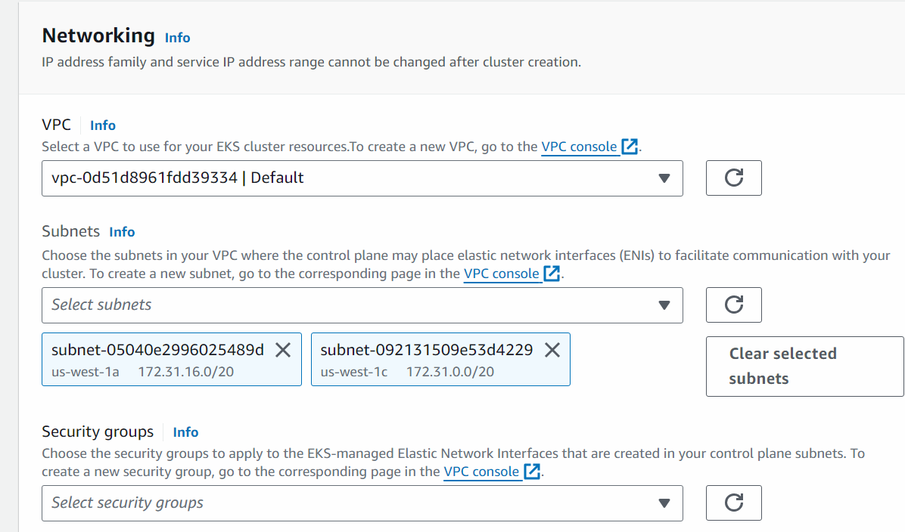
## DO NOT SELECT DEFAULT SECURITY GROUP

Go to ec2 -> go to security group -> create a security group will all traffic enabled

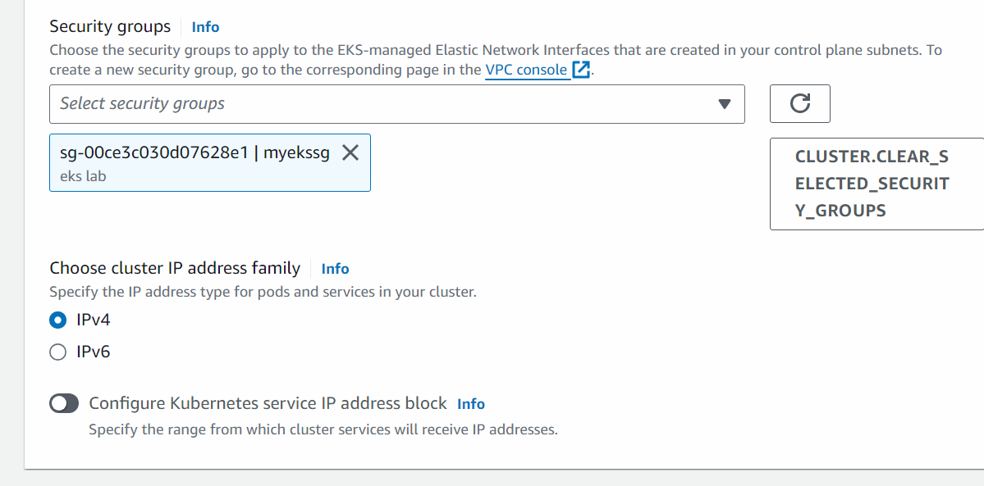

Next

Next

Next

Next

Create

After the EKS cluster is created then we will create the node group

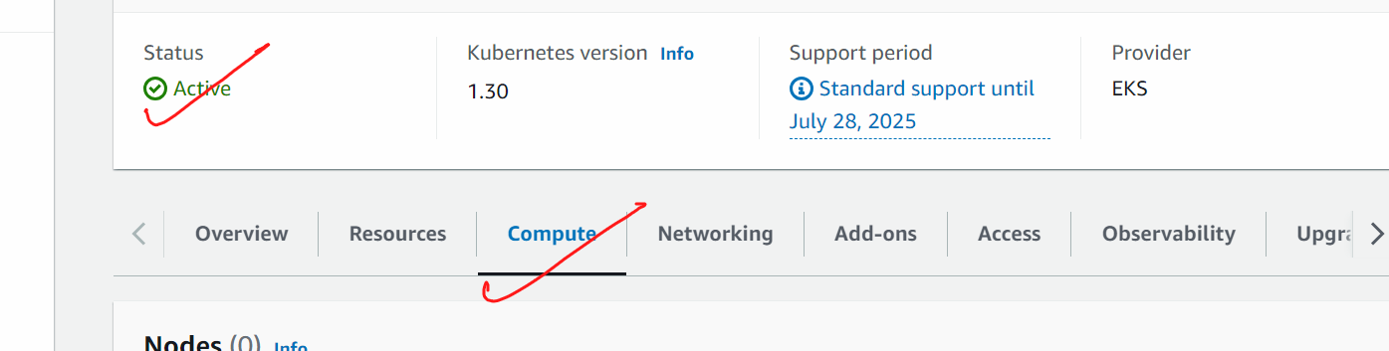

Add node group

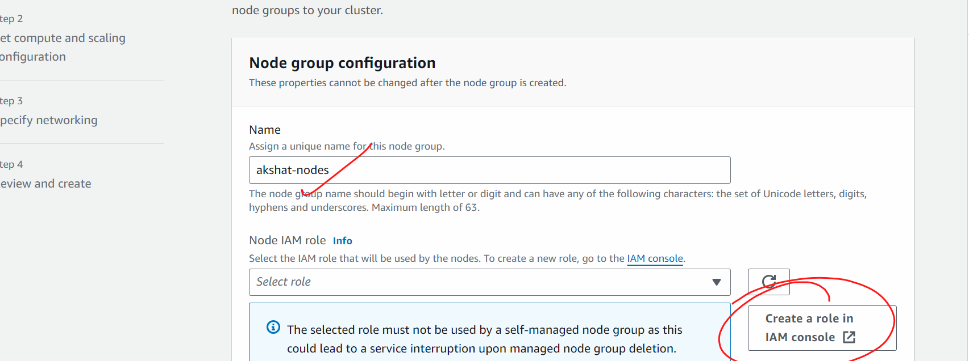

(in iam roles -< next -< next (permission will automatically set by aws) -> give some name -> create)

Next

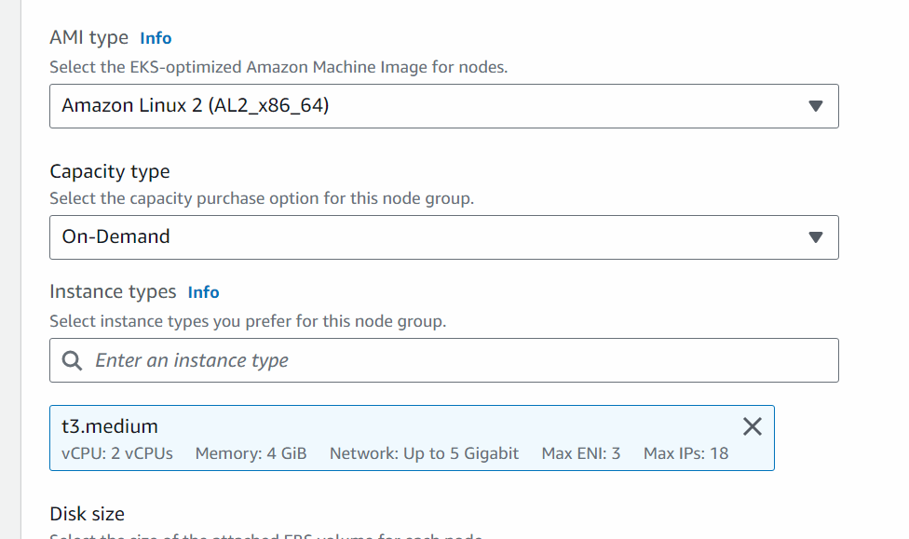

Next

Next

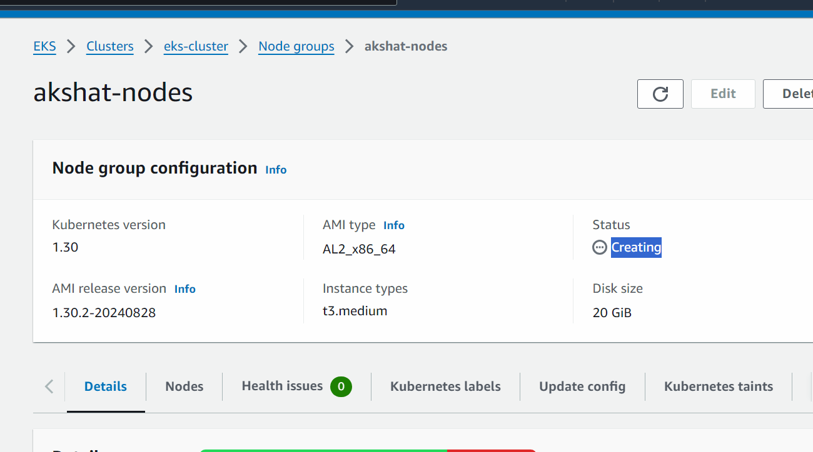

After the nodes are created we will connect the cluster from the ec2 machine so that we can talk to the cluster
Wait till the time node group is live

My eks service is now working…we need to access the eks from ec2 machine

Launch a ubuntu ec2 machine with all traffic enabled

Connect to the ec2 machine

#sudo su
# apt update
#we will now install aws cli

curl "https://awscli.amazonaws.com/awscli-exe-linux-x86_64.zip" -o "awscliv2.zip"
apt install unzip -y
unzip awscliv2.zip
sudo ./aws/install

We will generate access key and secret access keys
In the machine ,
# aws configure
Put access key and secret access keys there

Method1 to generate access key:

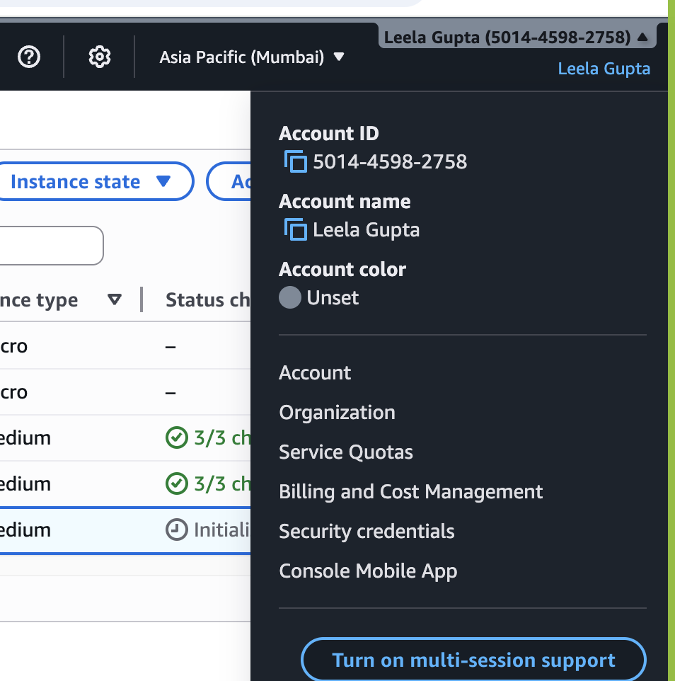
Clickon security credentials
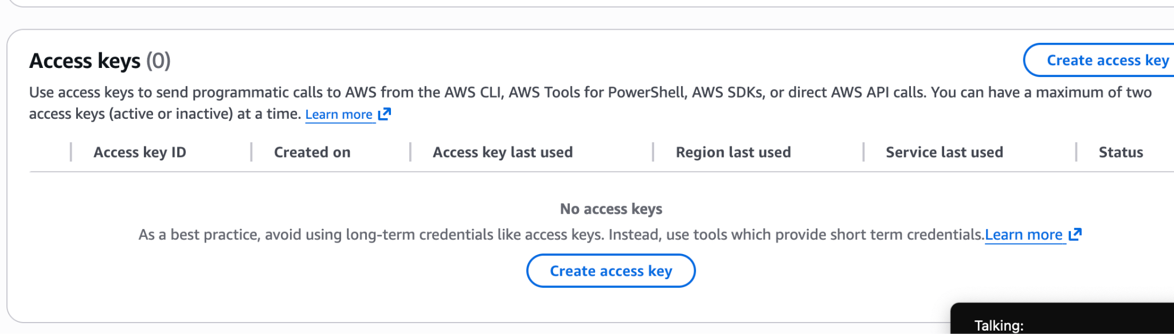

Create accesskey
Tick the checkbox
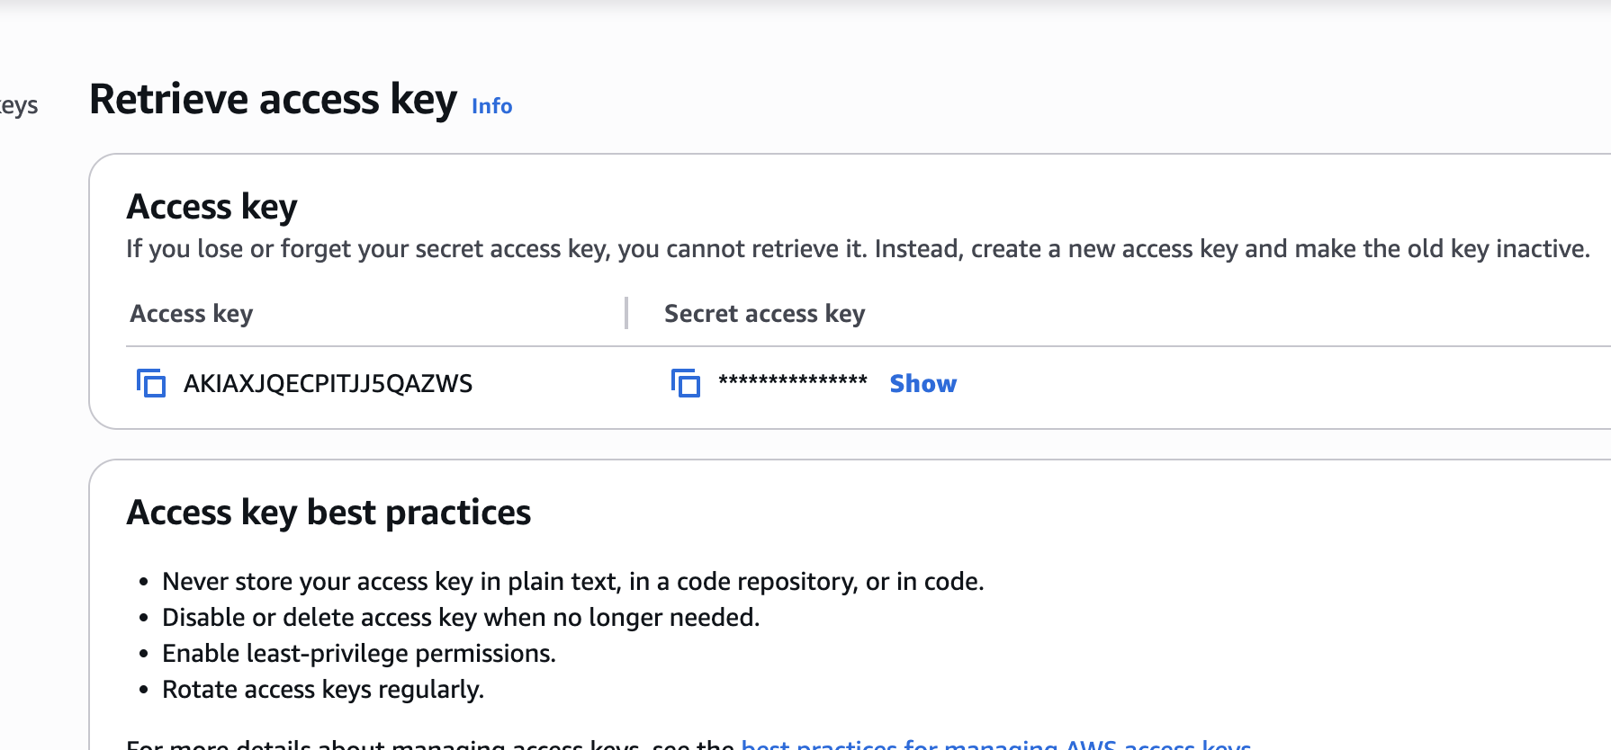
Copy then and put it in notepad

## go back to the machine

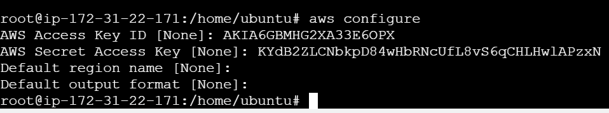

After this is done,,,,,

We will connect this machine with eks cluster

aws eks --region example_region update-kubeconfig --name cluster_name

(Here replace the example_region with the region where ur eks cluster is created and the cluster name should be the name of the cluster which u have kept)

sudo apt update
curl -LO "https://dl.k8s.io/release/$(curl -L -s https://dl.k8s.io/release/stable.txt)/bin/linux/amd64/kubectl"
chmod +x ./kubectl
sudo mv ./kubectl /usr/local/bin/kubectl
kubectl version --client
sudo curl --silent --location "https://github.com/weaveworks/eksctl/releases/latest/download/eksctl_$(uname -s)_amd64.tar.gz" | sudo tar xz -C /usr/local/bin
eksctl version

If you get the error 👍
Go to eks cluster -> compute -> click on node -> click on instance → security -> click on securty group -> edit inbound rule -> delete existing rule and allow all traffic

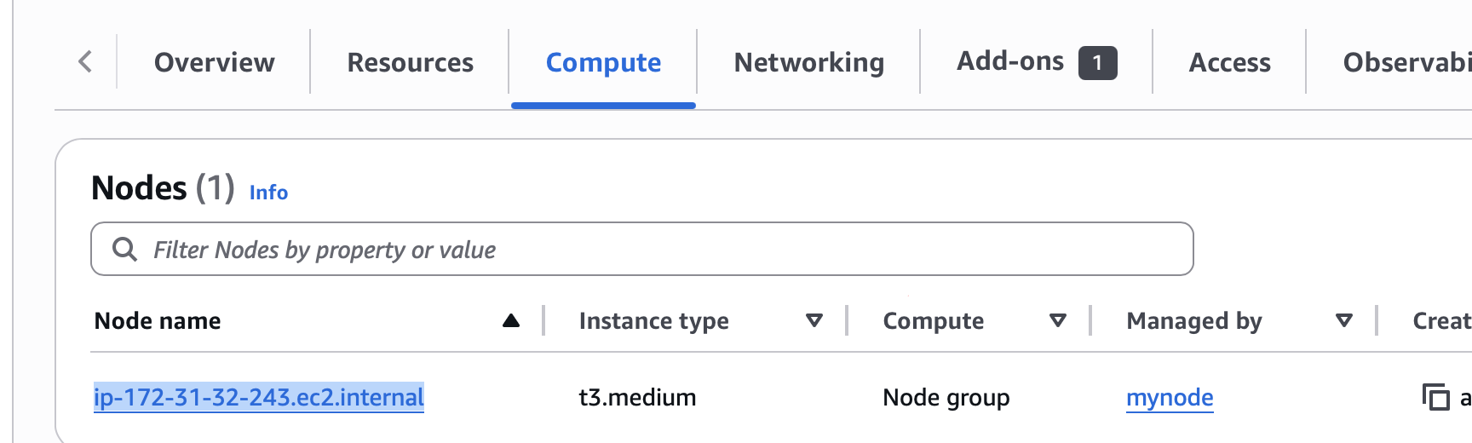
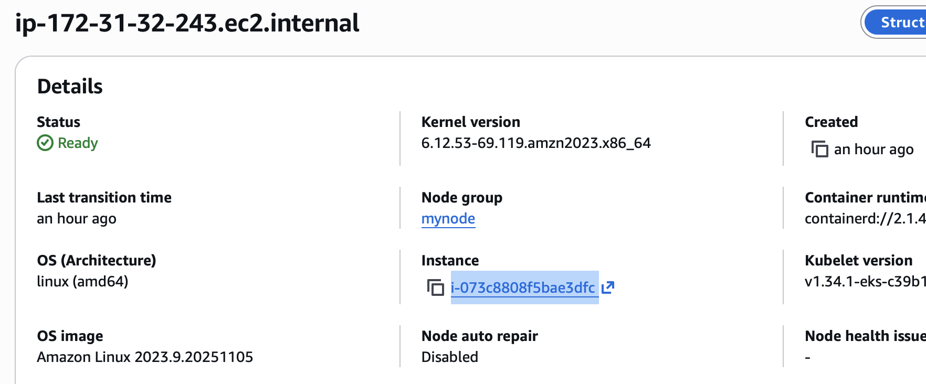
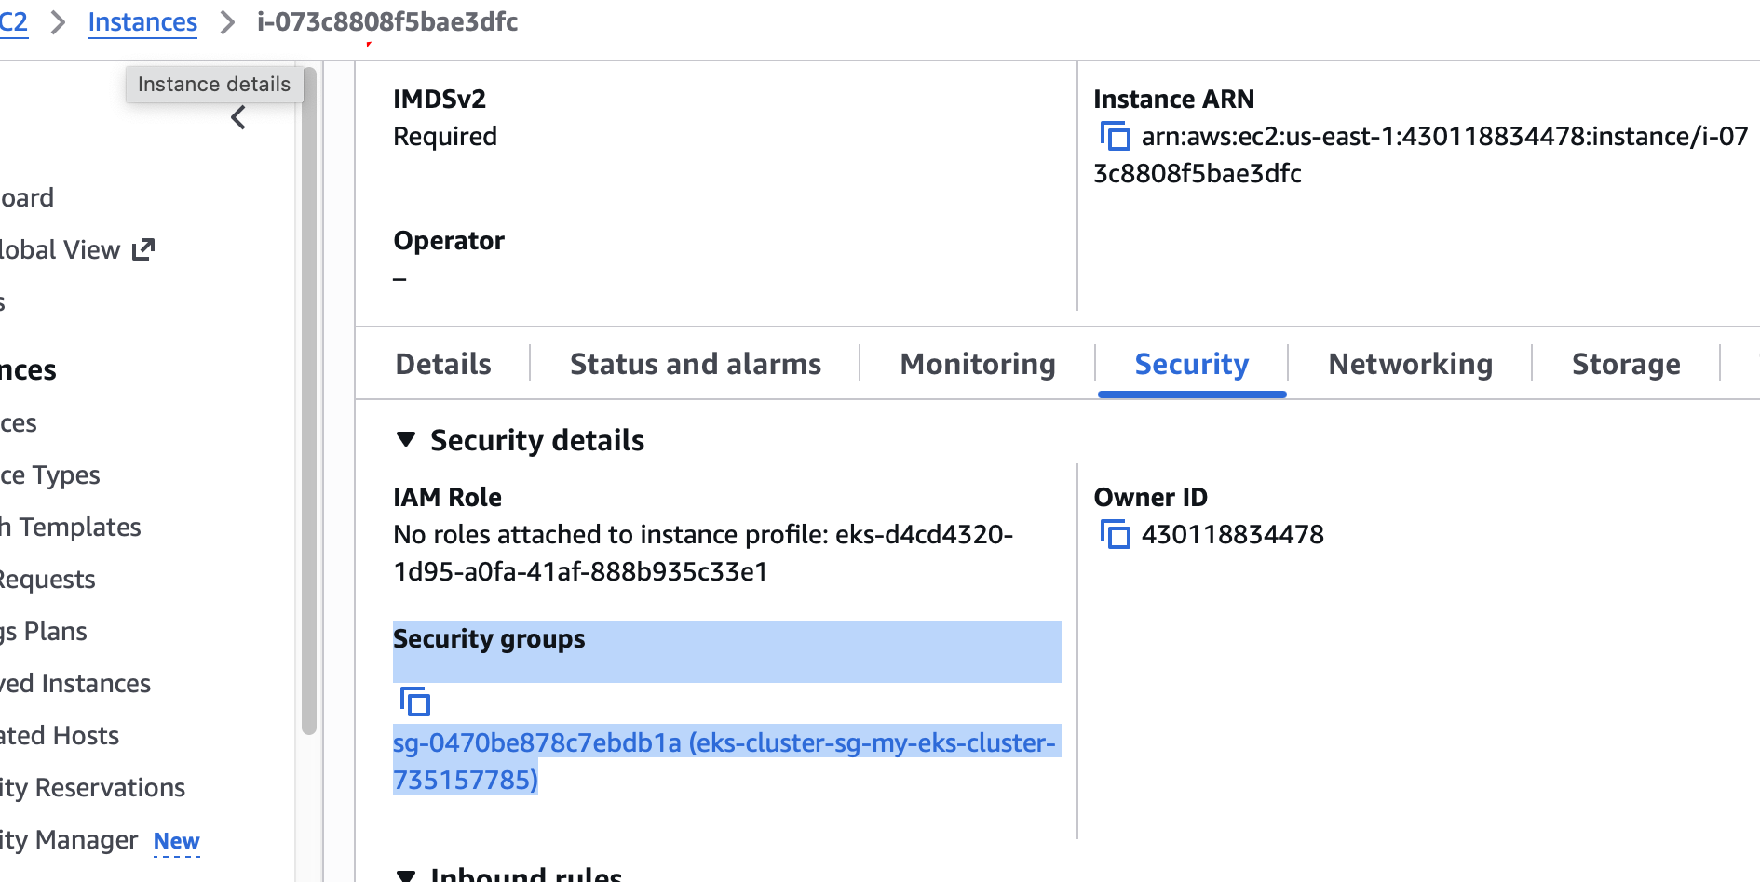

Edit inbound rule
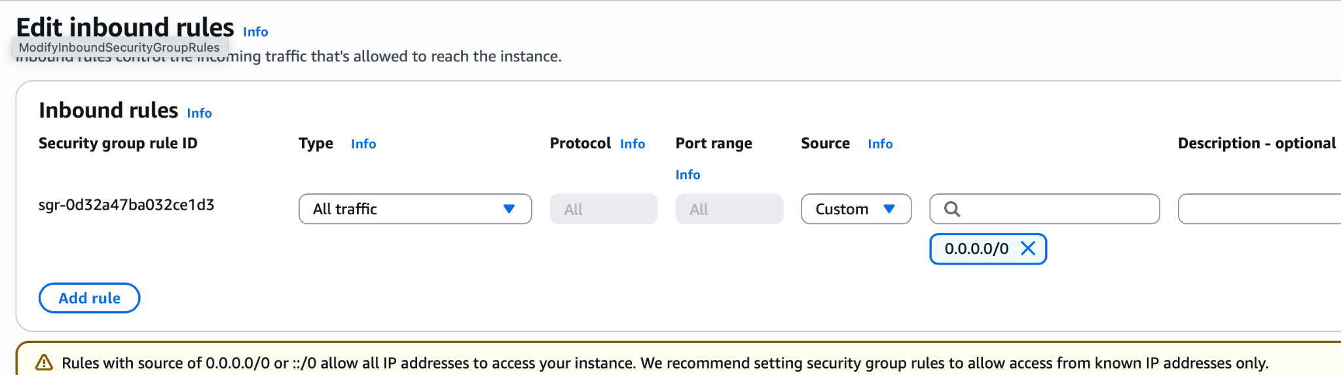
Save
kubectl get pods
# vi pod1.yml
